## 

**Operations Manual**

**ActiveCampaign**

**Version 0.1**

## Record of revision changes

|  |  |  |  |
| --- | --- | --- | --- |
| **Revision n°** | **Subject** | **Revision Date** | **Approved By** |
|  |  |  |  |
|  |  |  |  |
|  |  |  |  |
|  |  |  |  |
|  |  |  |  |
|  |  |  |  |
|  |  |  |  |
|  |  |  |  |
|  |  |  |  |
|  |  |  |  |
|  |  |  |  |
|  |  |  |  |
|  |  |  |  |
|  |  |  |  |

Table of contents

Record of revision changes 2

1. activecampaiGn overview 4

1.1 Purpose of ActiveCampaign 4

1.1.1 General 4

1.1.2 Logging Into Active Campaign. 4

2. Marketing 6

2.1 Procedures for marketing staff 6

STEP 1 6

STEP 2 7

STEP 3 7

STEP 4 8

STEP 5 8

STEP 6 9

STEP 7 9

STEP 8 10

STEP 9 10

Step 10 11

3. Support desk 11

# activecampaiGn overview

## Purpose of ActiveCampaign

### General

ActiveCampaign is a Customer Experience Automation platform that helps businesses connect and engage with customers. It creates optimized customer experiences by automating many behind-the-scenes marketing, sales, and support processes.

This will enable the company’s training send automated email delivery, blog scheduling and social media monitoring features which will help turn reluctant or uninformed leads into brand advocates.

Assist Sales: Built to nurture leads to close, the system makes the sales team’s job much easier.

### 1.1.2 Logging Into Active Campaign.

STEP 1 - Go to [activecampaign.com/login](https://www.activecampaign.com/login). Enter the account name the company’strainingliverpool into the ‘Account name’ box and click Login.

Company training company’strainingliverpool

STEP 2 You must have been given a username and password by IT Dept, if not please ask the IT Manager. Enter your given username and password Click Login.

**VERIFICATION**

Your screen should be as shown below. You will be asked for a verification code.

**TO GET THE VERIFICATION CODE**, Go to your email from Active Campaign

ENTER the 6 Digit verification code from the email sent to Active Campaign

Tick the box ‘Remember me for 45days’. Click on Verify. This will be repeated after every 45 days.

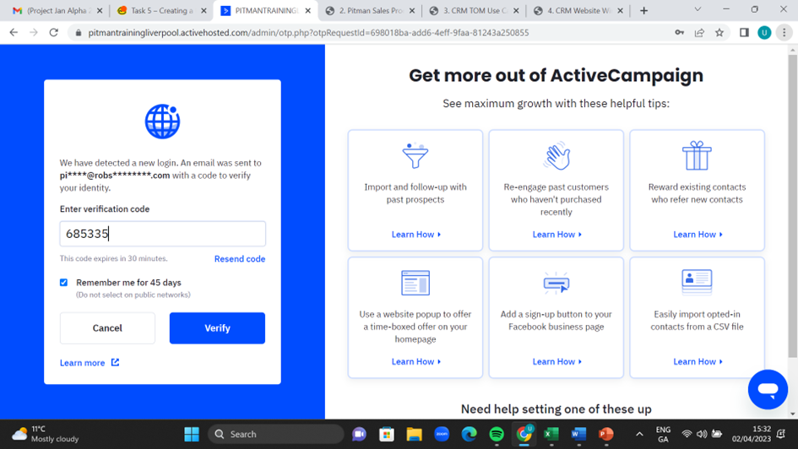

Tick this box

STEP 4 You will be routed to the **DASHBOARD**. Your screen should be as shown below.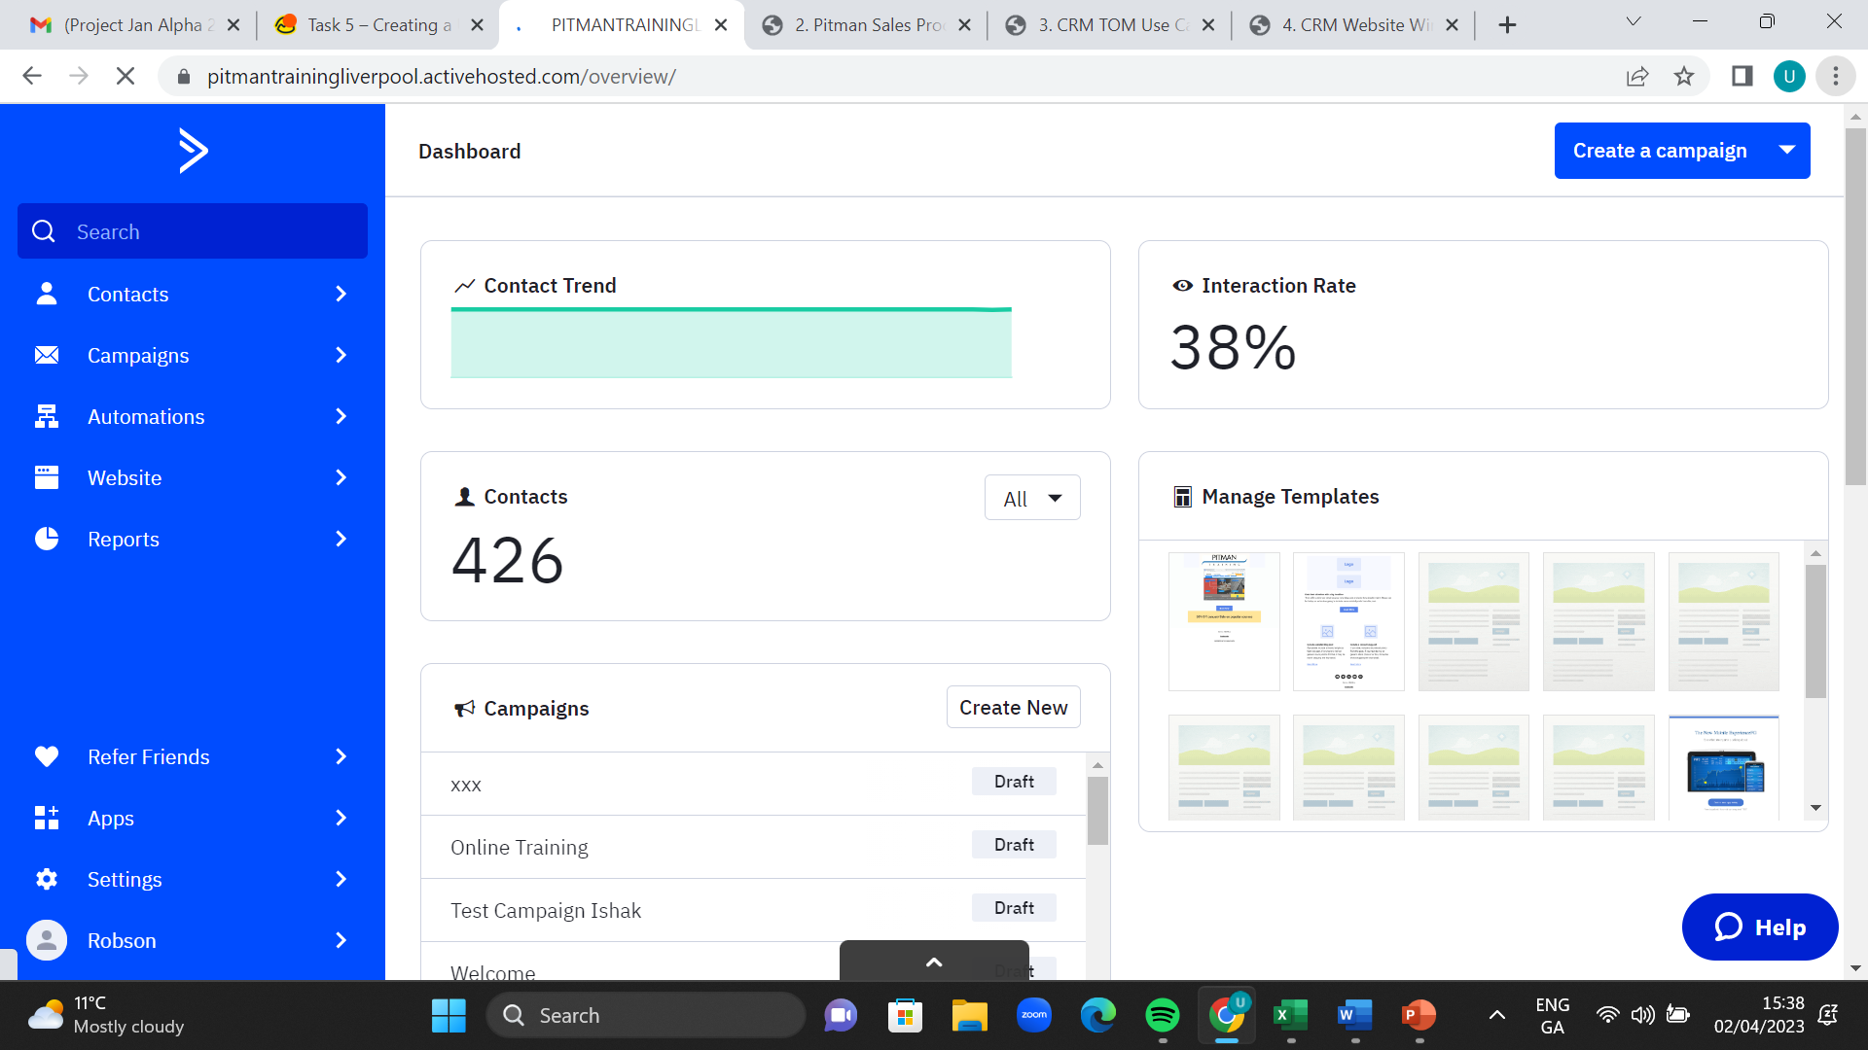

# Marketing

## Procedures for marketing staff

Active Campaign integrates with over 700 other Apps all marketing tasks can be automated in one place. Marketer can segment lists, create targeted campaigns and track results with detailed analytics.

STEP 1 Click on Contacts. Your screen should be as shown below. Click on a profile name.

A profile name.

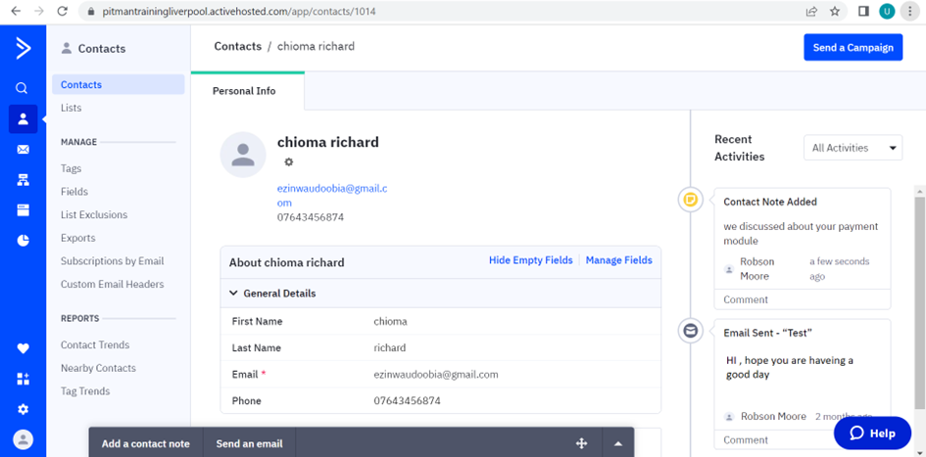

STEP 2 You have a choice to add a **note** and send an **email**. Write the mail and click on send email.

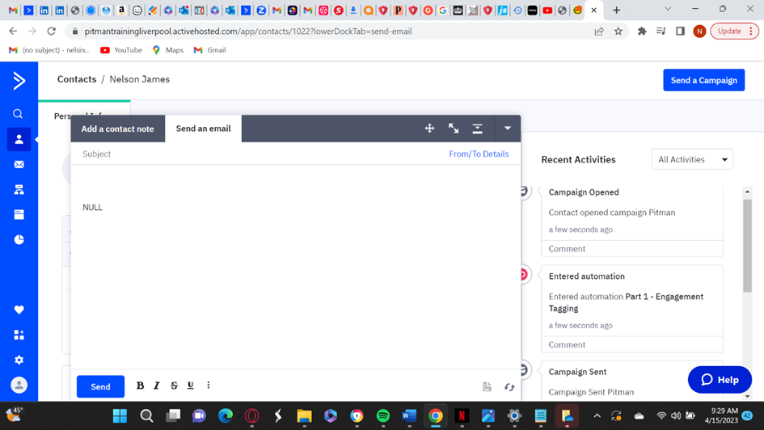

STEP 3 How to create a campaign

STEP 4 Your screen should be as shown below. ENTER name of compa and select CAMPAIGN TYPE of your choice. click on Next.

STEP 5 Select who you want to sent the campaign to and click NEXT

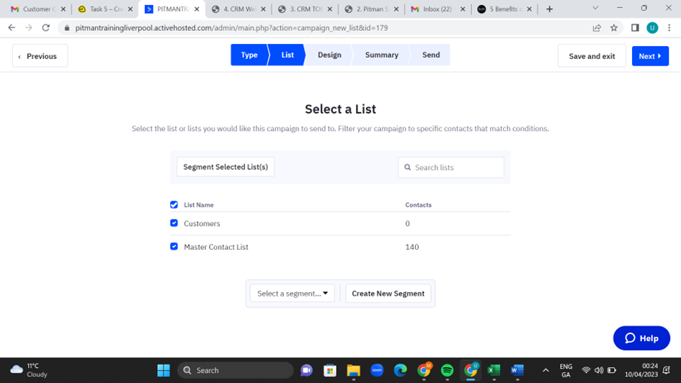

STEP 6 Your screen should be seen as shown below. Click design of choice and click on CONTINUE.

STEP 7 Your screen should be seen as shown below. You can choose to design from scratch or select a template of choice.

STEP 8 Type the email subject and click continue

STEP 9 Your screen should be seen as shown below. Click NEXT.

Step 10 Your screen should be seen as shown below . The campaign has been created. You can set a time to send the mail later , it can be automated at the scheduled time and date.You can save it and exist. Click send now when you are ready/scheduled date.

# Support desk

Please contact [support@the company’s-training.net](mailto:support@pitman-training.net) for any further queries.